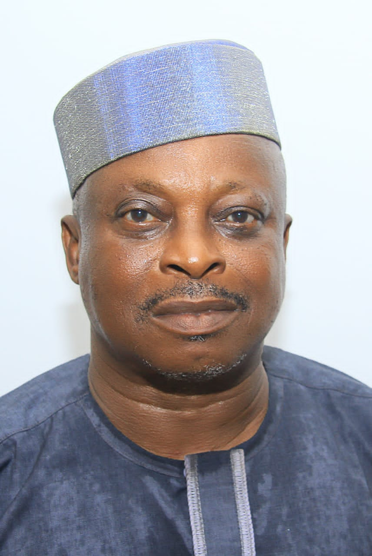

**ENGR.JOHNSON A. AJIBOYE, ELDER-IN-COUNCIL**